Composite Boundary in Solid Geometry
# Source: AI Source: Provided by: [Data Path: Persons Table -> ID Column: 1, Name_En Column: Motasem Essam] -> From: [ChatGPT] on [7/25/2026]
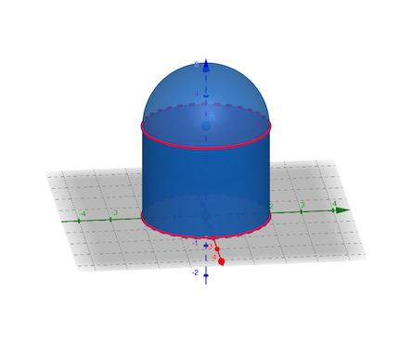
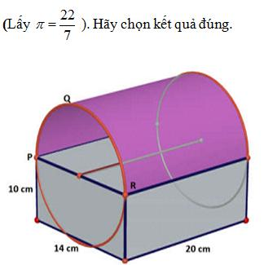
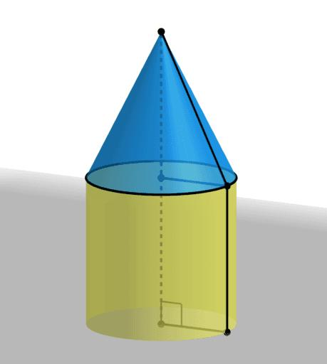

Definition
# Source: AI Source: Provided by: [Data Path: Persons Table -> ID Column: 1, Name_En Column: Motasem Essam] -> From: [ChatGPT] on [7/25/2026]
A composite boundary in solid geometry is the boundary of a three-dimensional solid that consists of two or more different types of surface portions joined together. These portions may include flat polygonal faces and curved surfaces.
A composite boundary can combine:
- Planar surfaces: flat surfaces, such as rectangles, squares, triangles, and circles.
- Curved surfaces: surfaces that bend, such as cylindrical, conical, and spherical surfaces.
- Joining edges or curves: the lines or curves where different surface portions meet.
For example, a solid formed by placing a hemisphere on top of a cylinder has a composite boundary made of a curved hemispherical surface, a curved cylindrical surface, and a flat circular base. The circular interface between the hemisphere and cylinder is internal to the combined solid and is not part of its external boundary.

Simple definition
# Source: AI Source: Provided by: [Data Path: Persons Table -> ID Column: 1, Name_En Column: Motasem Essam] -> From: [ChatGPT] on [7/25/2026]
A composite boundary is the outside surface of a solid made by joining different surface shapes together.
Example: A building shaped like a rectangular box with a triangular-prism roof has a composite boundary because its outside includes rectangular and triangular flat faces.

Classification tree
# Source: AI Source: Provided by: [Data Path: Persons Table -> ID Column: 1, Name_En Column: Motasem Essam] -> From: [ChatGPT] on [7/25/2026]
Composite Boundary in Solid Geometry
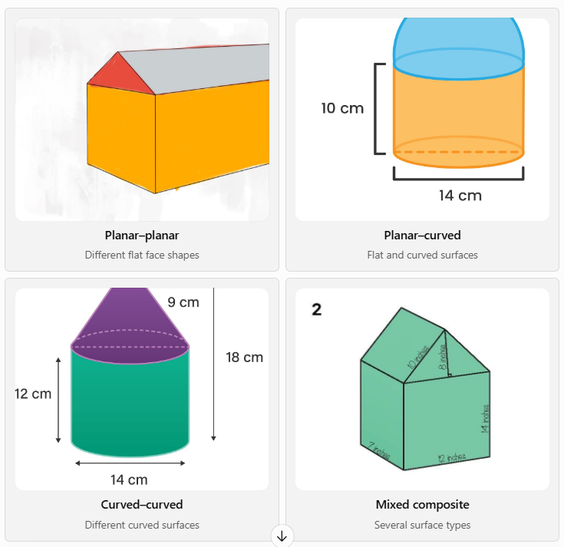
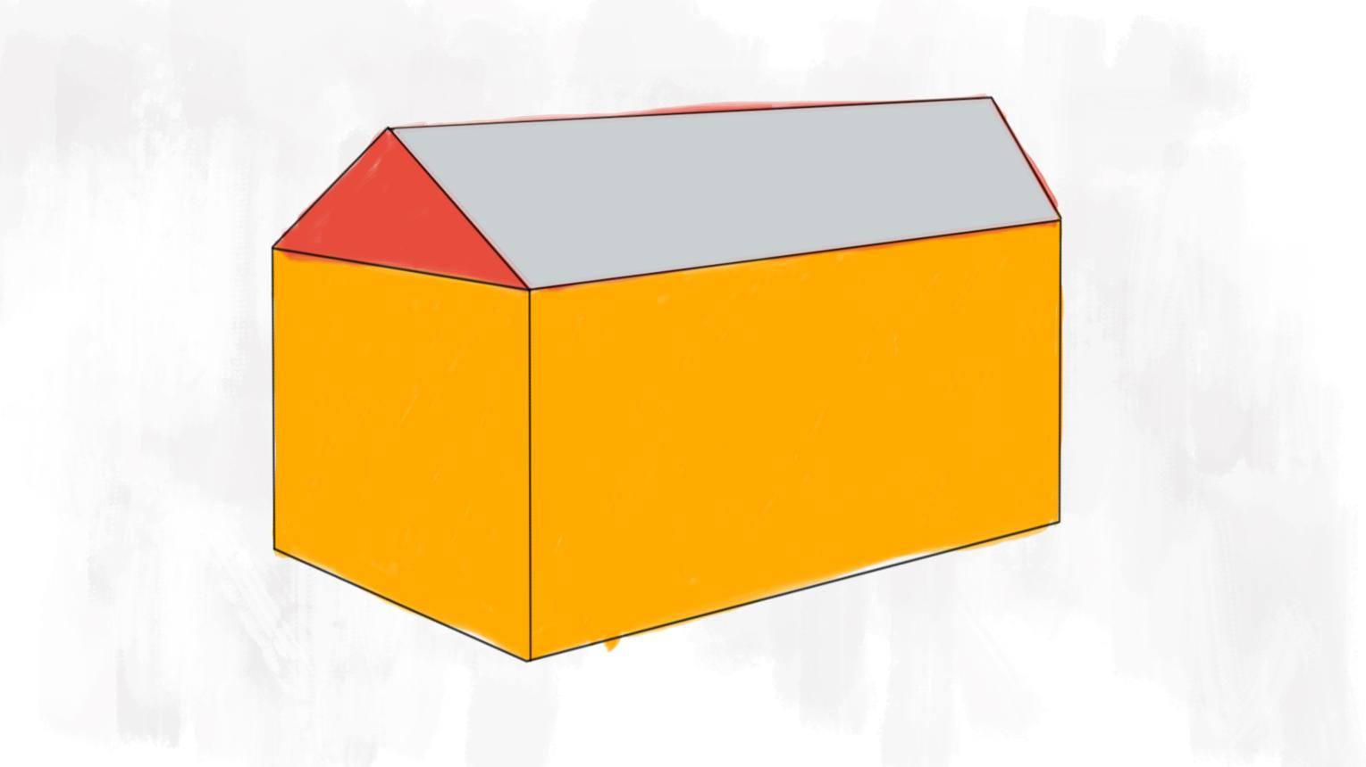
Planar–planar
Different flat face shapes
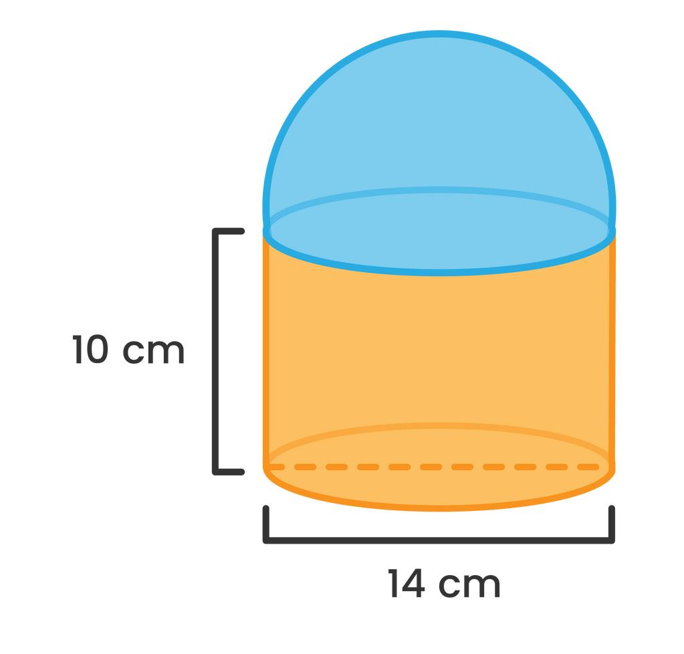
Planar–curved
Flat and curved surfaces

Curved–curved
Different curved surfaces
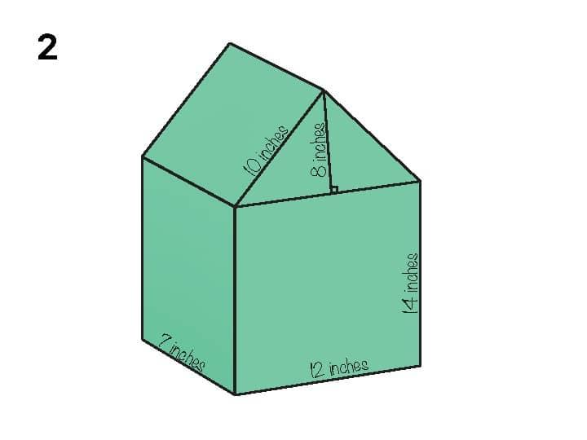
Mixed composite
Several surface types
Note: These are useful descriptive categories rather than a single universally standardized classification.

Key characteristics
# Source: AI Source: Provided by: [Data Path: Persons Table -> ID Column: 1, Name_En Column: Motasem Essam] -> From: [ChatGPT] on [7/25/2026]
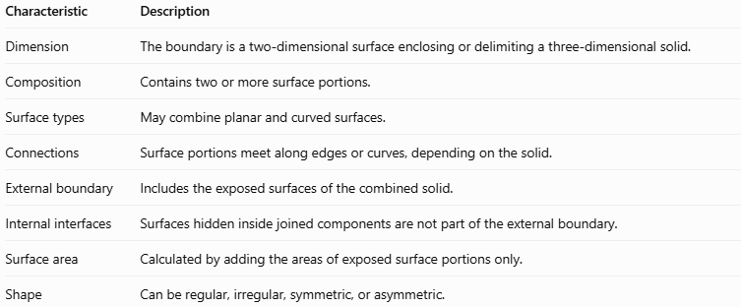
Characteristic | Description
Dimension | The boundary is a two-dimensional surface enclosing or delimiting a three-dimensional solid.
Composition | Contains two or more surface portions.
Surface types | May combine planar and curved surfaces.
Connections | Surface portions meet along edges or curves, depending on the solid.
External boundary | Includes the exposed surfaces of the combined solid.
Internal interfaces | Surfaces hidden inside joined components are not part of the external boundary.
Surface area | Calculated by adding the areas of exposed surface portions only.
Shape | Can be regular, irregular, symmetric, or asymmetric.

Geometric representation
# Source: AI Source: Provided by: [Data Path: Persons Table -> ID Column: 1, Name_En Column: Motasem Essam] -> From: [ChatGPT] on [7/25/2026]
Consider a cylinder with a hemisphere attached to its top.
Its external boundary consists of:
- The curved surface of the hemisphere.
- The curved lateral surface of the cylinder.
- The flat circular bottom of the cylinder.
The circular face joining the hemisphere to the cylinder is hidden inside the combined solid, so it is excluded from the external boundary.
Other examples

A. House-shaped solid
# Source: AI Source: Provided by: [Data Path: Persons Table -> ID Column: 1, Name_En Column: Motasem Essam] -> From: [ChatGPT] on [7/25/2026]
The boundary combines rectangular faces with triangular faces. This is a composite boundary made entirely of planar surfaces.
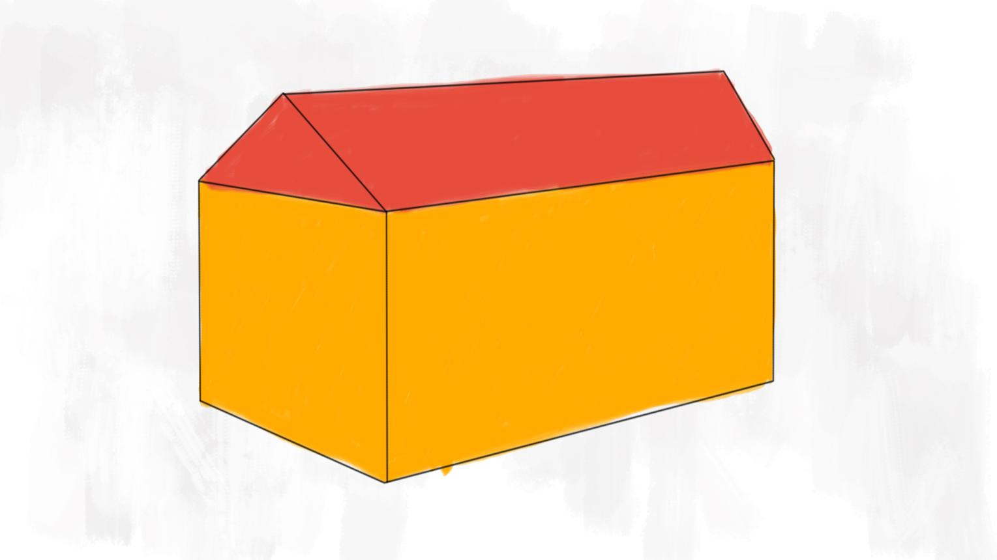

B. Cylinder with a cone on top
# Source: AI Source: Provided by: [Data Path: Persons Table -> ID Column: 1, Name_En Column: Motasem Essam] -> From: [ChatGPT] on [7/25/2026]
The exposed boundary contains a cylindrical curved surface, a conical curved surface, and a flat circular base.

C. Box with a curved roof
# Source: AI Source: Provided by: [Data Path: Persons Table -> ID Column: 1, Name_En Column: Motasem Essam] -> From: [ChatGPT] on [7/25/2026]
The boundary includes flat rectangular surfaces and a curved roof surface.
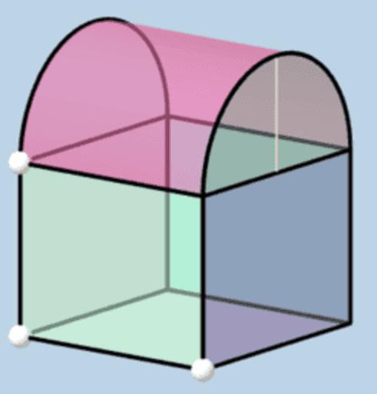

6. Mathematical representations
# Source: AI Source: Provided by: [Data Path: Persons Table -> ID Column: 1, Name_En Column: Motasem Essam] -> From: [ChatGPT] on [7/25/2026]
A composite boundary generally does not have one universal equation. Its mathematical representation depends on the surfaces forming the solid.

A. Surface-area formula
# Source: AI Source: Provided by: [Data Path: Persons Table -> ID Column: 1, Name_En Column: Motasem Essam] -> From: [ChatGPT] on [7/25/2026]
For a composite solid whose exposed boundary consists of several surface portions,
$$A_{\text{boundary}}=\sum_{i=1}^{n}{A_{i}}$$
where:
- $A_{\text{boundary}}$ is the total external surface area.
- $A_{i}$ is the area of each exposed surface portion.
- $n$ is the number of exposed portions included in the calculation.
Important: Do not count hidden joining surfaces.

B. Cylinder with a hemisphere on top
# Source: AI Source: Provided by: [Data Path: Persons Table -> ID Column: 1, Name_En Column: Motasem Essam] -> From: [ChatGPT] on [7/25/2026]
Let the cylinder have radius $r$ and height $h$, and let the hemisphere have the same radius $r$.
The exposed surface consists of:
- Hemisphere curved area: $2πr^{2}$
- Cylinder lateral area: $2πrh$
- Cylinder bottom area: $πr^{2}$
Therefore,
$$\begin{aligned}A_{\text{boundary}}&=2πr^{2}+2πrh+πr^{2} \\ &=3πr^{2}+2πrh\end{aligned}$$
The circular joining face is excluded because it is internal.

C. House-shaped solid
# Source: AI Source: Provided by: [Data Path: Persons Table -> ID Column: 1, Name_En Column: Motasem Essam] -> From: [ChatGPT] on [7/25/2026]
A house-shaped solid formed from a rectangular prism and a triangular-prism roof has planar faces of different shapes. Its total external area is the sum of the exposed rectangles and triangles, excluding any faces hidden where the two components meet.

Worked examples
# Source: AI Source: Provided by: [Data Path: Persons Table -> ID Column: 1, Name_En Column: Motasem Essam] -> From: [ChatGPT] on [7/25/2026]
Example 1: Cylinder with a hemispherical top
A solid consists of a cylinder of radius $3\text{ cm}$ and height $8\text{ cm}$, with a hemisphere of radius $3\text{ cm}$ on top. Find its external surface area.
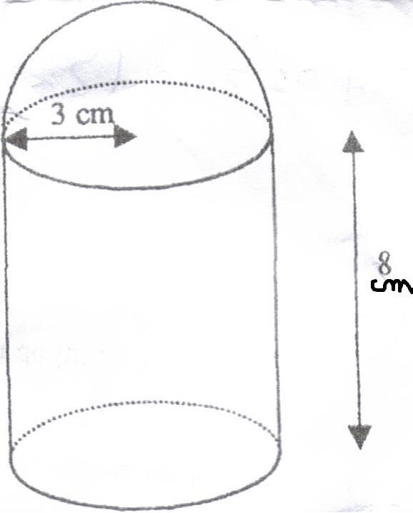
Step 1: Identify the exposed surfaces.
- Hemisphere: $2πr^{2}$
- Cylinder side: $2πrh$
- Bottom circle: $πr^{2}$
Step 2: Substitute the measurements.
$$\begin{aligned}A&=2π{\left(3\right)}^{2}+2π\left(3\right)\left(8\right)+π{\left(3\right)}^{2} \\ &=18π+48π+9π \\ &=75π{\text{ cm}}^{2}\end{aligned}$$
Answer:
$$\boxed{75π{\text{ cm}}^{2}≈235.62{\text{ cm}}^{2}}$$
Example 2: A box with a roof
A rectangular prism has length $10\text{ cm}$, width $6\text{ cm}$, and height $4\text{ cm}$. A triangular-prism roof is attached on top. Suppose the roof's two sloping rectangular faces each have dimensions $10\text{ cm}×5\text{ cm}$, and its two triangular ends each have a base of $6\text{ cm}$ and height $4\text{ cm}$.
Find the external surface area, assuming the roof's bottom and the box's top are joined and hidden.
Step 1: Calculate the exposed faces of the box.
- Bottom: $10×6=60$
- Two long side faces: $2\left(10×4\right)=80$
- Two end faces: $2\left(6×4\right)=48$
Total exposed box area:
$$60+80+48=188{\text{ cm}}^{2}$$
Step 2: Calculate the exposed roof faces.
- Two sloping rectangles: $2\left(10×5\right)=100$
- Two triangular ends: $2\left(\frac{12}{×}6×4\right)=24$
Total exposed roof area:
$$100+24=124{\text{ cm}}^{2}$$
Step 3: Add the exposed areas.
$$A_{\text{boundary}}=188+124=\boxed{312{\text{ cm}}^{2}}$$
The shared joining face is excluded. This calculation assumes the given roof dimensions describe the exposed faces and that the stated triangular ends are the roof's actual end faces.

Comparison with related boundary types
# Source: AI Source: Provided by: [Data Path: Persons Table -> ID Column: 1, Name_En Column: Motasem Essam] -> From: [ChatGPT] on [7/25/2026]
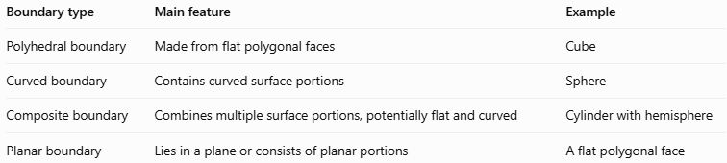
Boundary type | Main feature | Example
Polyhedral boundary | Made from flat polygonal faces | Cube
Curved boundary | Contains curved surface portions | Sphere
Composite boundary | Combines multiple surface portions, potentially flat and curved | Cylinder with hemisphere
Planar boundary | Lies in a plane or consists of planar portions | A flat polygonal face
A composite boundary is not necessarily partly curved: a solid made from joined polyhedral components can also have a composite boundary.

Applications
# Source: AI Source: Provided by: [Data Path: Persons Table -> ID Column: 1, Name_En Column: Motasem Essam] -> From: [ChatGPT] on [7/25/2026]
Composite boundaries appear in many real-world objects:
- Architecture: houses with pitched roofs, domes, and curved entrances.
- Engineering: tanks, pipes, machine housings, and joined components.
- Manufacturing: molded products made from several geometric forms.
- Packaging: containers with flat bodies and rounded tops.
- Mathematics: calculating surface area and describing the outer shape of composite solids.

Key points
# Source: AI Source: Provided by: [Data Path: Persons Table -> ID Column: 1, Name_En Column: Motasem Essam] -> From: [ChatGPT] on [7/25/2026]
- A composite boundary consists of two or more joined surface portions.
- It can contain flat surfaces, curved surfaces, or both.
- The external boundary includes only surfaces exposed on the outside of the combined solid.
- Hidden joining faces must be excluded when calculating external surface area.
- The correct formula depends on the geometry of each exposed surface.
- Composite boundaries can occur in both regular and irregular solids.

Conclusion
# Source: AI Source: Provided by: [Data Path: Persons Table -> ID Column: 1, Name_En Column: Motasem Essam] -> From: [ChatGPT] on [7/25/2026]
A composite boundary in solid geometry describes the outer surface of a three-dimensional solid assembled from different surface portions. Understanding how those portions join makes it easier to classify solids, represent their geometry, and calculate their external surface area accurately.

